The HSA_UFA Console: Text Output

# Creating the Console Window

The Console window is the window that pops up when you run a program that uses the hsa_new console. The console is a Java **object**. The console window contains a text grid that by default holds 25 lines by 80 columns of text. The user can input data directly in the Console window and the output of the program appears there too.

Console title

Program output

Row 0 Column 0

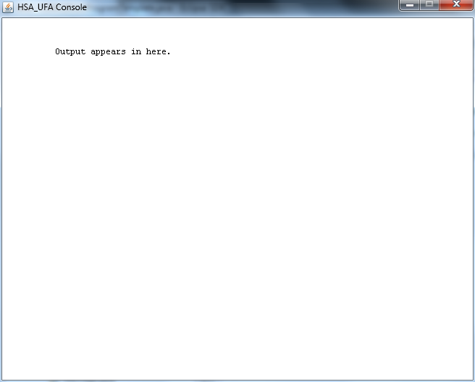

Row 28 Column 91

650 pixels wide

(about 92 columns)

500 pixels high (about 26 rows)

When you are creating a console, you can specify its size, the size of the font it will use, and the title that should appear in the window, like this:

**c = new Console ();**

Creates a console window named “c” with the default size (656 pixels wide, 532 pixels high) using the default font size (set in File🡪Preferences🡪Run Window), and no title.

**c = new Console (*“title”*)**

Creates a console window named “c” with default size, but with your title for the window.

**c = new Console (*width*, *height*);**

Creates a console named “c” of whatever size you like, depending on what you put for *width* and *height* (values are in pixels).

**c = new Console (*width*, *height*, *fontSize*)**

As above, but also specifies the size of the font to be used in the output window.

**c = new Console (*width*, *height*, *fontSize, “title”*)**

As above, but also specifies a title for the window.

*Note: You can also open two consoles at once. Can you figure out how?*Basic Text Output

For basic text output, the console is divided into **rows** and **columns**. The top left corner is row 0 and column 0. When you print something to the screen, where it appears is controlled by an invisible pointer called the **cursor**. The cursor starts in the top left corner (row 0, column 0) and moves to the right and down (increasing columns and rows) depending on how many characters you output.

The row number increases whenever you reach the end of a line, or when you output a **line feed** character. A line feed increases the row number by 1, and sets the column number to 0. When you reach the bottom of the screen, the output starts to scroll.

# Text Output Methods

**Important:** Don’t forget to put the name of the console and a dot (most of the time, it’s “c.”) before each of these when you use them in your programs.

**clear ()**

Clears the Console window and sets the cursor to the upper-left corner (*row =* 0, *column =* 0).

**print (*String or other printable data*)**

Prints whatever you put in the brackets, starting from the current cursor position and moving to the right (and down if you reach the end of the line). Usually, you put a **string** in the brackets, like “hello world” or “12345”.. You can also print plain numbers without the quotation marks.

**println ()**

Outputs a line feed at the current cursor position, which moves the cursor down one line (*row +* 1)and all the way to the left (*column =* 0)

**println (*String, words in double quotation marks, or other printable stuff*)**

Identical to print, except that a **line feed** is output after the argument. This means that the next time you use c.print or c.println the text will come out on the next line.

**setColor (*Color*)**

Sets the color for text output from *print* and *println* methods. See the Colors handout.

**setBackgroundColor (*Color*)**

Sets the background color for text output from print and println methods. See Colors handout.

**setCursor (*row*, *column*)**

Sets the cursor position to row *row* and column *col*.

If you put \n inside a string, it will go down to the next line. If you put \t, it will insert a tab. Try this:

c.print(“Hello\nWorld.\tbye now”);

**close()**

Closes the console window.

#### Quick Quiz

Draw the exact output for each of these two sequences of statements.

c.print(“Hello ”); c.println(“Hello ”);

c.print(“world.”); c.println(“world.”);

c.println(“Goodbye.”); c.println(“Goodbye.”);